**Week 9- LAB 6**

1. **First question:**

Write a java program that:

* Create an array of 10 integers.
* Create an array of 5 Boolean.
* Create an array of 3 String.
* Print the content of each array.

**Typical run of the program**

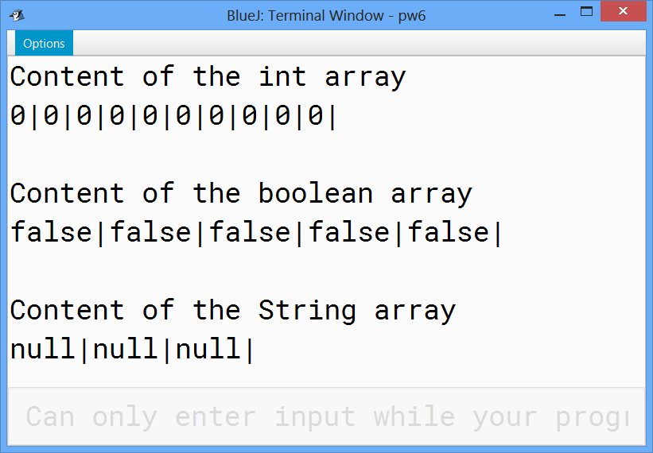

1. **Second question**

Write a java program that:

* Create an array of 10 integers.
* Print the content of the array.
* Change the value of the first element to 11.
* Change the value of the last element to 1.
* Print the content of the array.

**Typical run of the program**

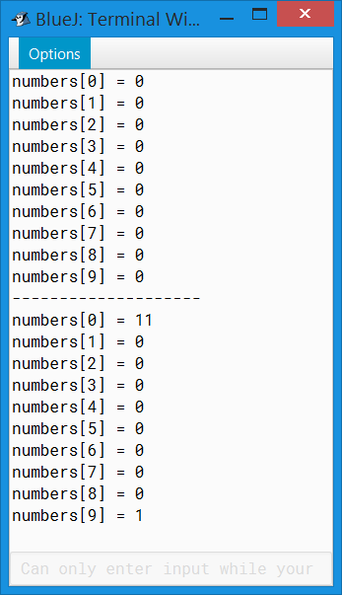

1. **Third question**

Write a java program that:

* Create an array of 3 String.
* Initialize the first element with your firs name.
* Initialize the second element with your last name.
* Initialize the third element with your father name.
* Print the content of the array using **enhanced for loop**.

**Typical run of the program**

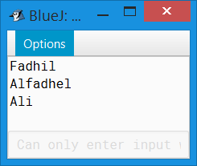

1. **Fourth question:**

Write java program that:

* Ask the user to give a positive number between 10 and 20.
* Create an array of integer. The length of the array is the given number by the user.
* Print the content of the array
* Fill the array with numbers from 0 to the given number -1.
* Print the content of the array
* Fill the array with positive random numbers less than 200.
* Print the content of the array.
* Find and print :
  + - The odd numbers, the maximum and the minimum numbers.
    - The sum and the average.

**Typical output**

Please give a number between 10 and 20

12

The state of the array before initialization

0 0 0 0 0 0 0 0 0 0 0 0

The state of the array after initialization

0 1 2 3 4 5 6 7 8 9 10 11

The state of the array after random filling

54 48 102 149 102 174 111 99 85 189 35 133

The odd numbers are

149 111 99 85 189 35 133

the sum is :1281.0

the avg is :106.75

the max is :189

the min is :35

1. **Fifth question:**

Write java program that:

* Ask the user to give a number between 2 and 5.
* Create an array of int. The length of the array is equal to the given number.
* Ask the user to fill the array element by element.
* Ask the user to enter a position then print the array content of this position. If the user enters a wrong number, then an exception occurs.

**Typical run of the program**

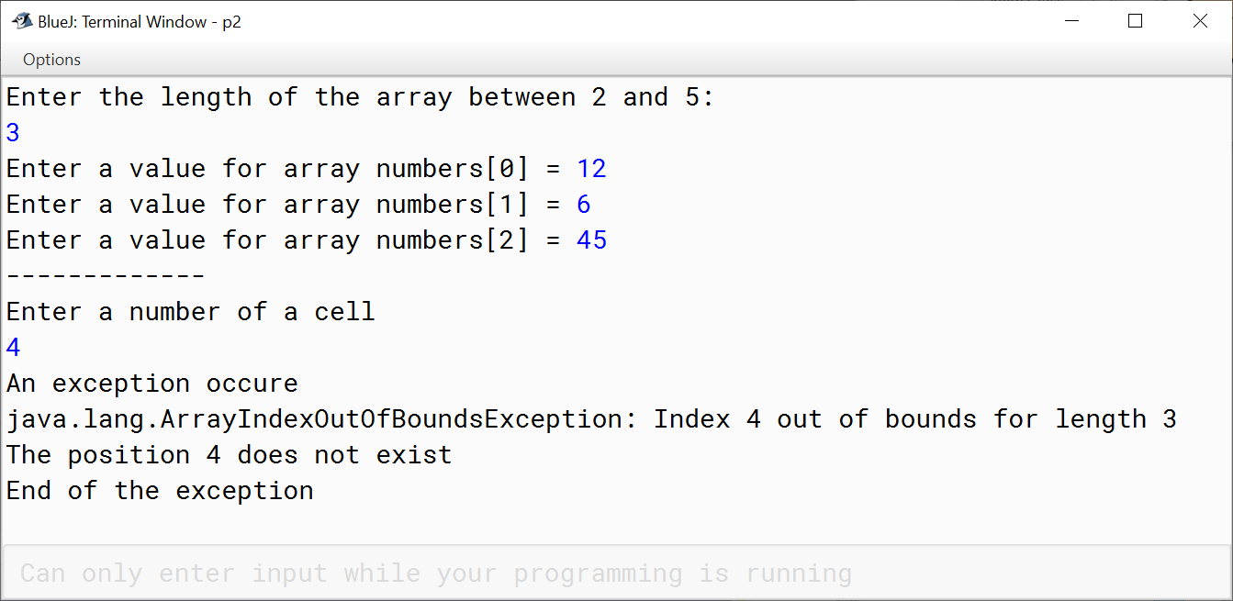

1. **Sixth question**

Write a java program that:

* Create an array of 20 integers.
* Initialize the first element with 20, the second element with 19…the last element with 1.
* Print the content of each array.
* Change the value of the first element to 3 (1*3), the second element to 6 (2*3)… the last element to 60 (20*3).
* Print the content of the array.

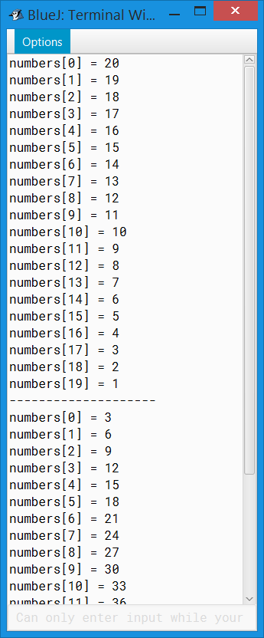**Typical run of the program**